CONFIDENTIAL



UNIVERSITI TEKNOLOGI MALAYSIA
FINAL EXAM SEMESTER II, 2023/2024

SUBJECT CODE : SECJ2154

SUBJECT NAME : OBJECT ORIENTED PROGRAMMING YEAR/PROGRAM : 2 (SECB/ SECJ/ SECP/ SECR/ SECV) DURATION : 3 HOURS
DATE :

VENUE :
------------------------------------------------------------------------------------------------------------

INSTRUCTIONS:
THIS EXAMINATION BOOK CONSISTS OF 2 SECTIONS:
SECTION A: Structured Questions 70 Marks
SECTION B: Programming 30 Marks

ANSWER ALL QUESTIONS IN THE ANSWER BOOKLET.
THE QUESTION BOOKLET MUST BE RETURNED WITH THE ANSWER BOOKLET

(Please write your lecturer name and section in your answer booklet)

Name
IC
Year/Program
Section
Lecturer Name
This question paper consists of 12 pages excluding this page.

PART A: STRUCTURED QUESTION [70 MARKS]
Part A consists of five (5) structured questions. Write your answers in the answer booklet.

Question 1 (10 marks)
Analyze the following Java program in Figure 1.1 below :

1 | import java.util.ArrayList;
2 | import java.util.Vector;
3
4 | public class AQList{
5 | public static void main(String[] args) {
6 | ArrayList<String> arrayList = new ArrayList<>();
7 | arrayList.add("Banana");
8 | arrayList.add("Olive");
9 | arrayList.add("Date");
10 | arrayList.add("Fig");
11 | System.out.println("List: " + arrayList);
12
13 | Vector<String> vector = new Vector<>();
14 | vector.add("Ants");
15 | vector.add("Bee");
16 | vector.add("Cow");
17 | vector.add("Dog");
18 | System.out.println("Vector: " + vector);
19
20 | arrayList.set(1, "Grape");
21 | arrayList.remove(0);
22
23 | vector.remove("Cow");
24 | vector.setElementAt("Fish",2);
25
26 | System.out.println("List: " + arrayList);
27 | System.out.println("Vector: " + vector);
28 | }
29 | }
Figure 1.1: AQList class definitions Answer the given question based on Figure 1.1 AQList class
- The output for line 11 is : (2 marks)
- The output for line 18 is : (2 marks)
- The output for line 26 is : (3 marks)
- The output for line 27 is : (3 marks)

Question 2 (15 marks)
Analyze the class diagram and incomplete program that represents the class House, Furniture, and
Room relationship.
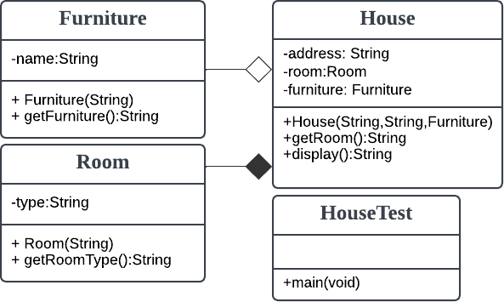
Figure 2.1: Class Diagram of House, Furniture, Room

Given Figure 2.2, class HouseTest for the main method implementation.
// class HouseTest public class HouseTest {
public static void main(String[] args) { Furniture fur1 = new Furniture("Sofa");
House house = new House("No 2 Taman U", "Bedroom",fur1); System.out.println(house.display());
}
}
1
2
3
4
5
6
7
8
Figure 2.2: HouseTest class definitions

1 | //class House
2 | class House {
3
4
5
6
7 | public House( , , ) {
8
9
10
11 | }
12
13 | public String getRoom(){
14 | return ;
15 | }
16
17 | public String display(){
18 | return ;
19 | }
20 | }
Figure 2.3: House class definitions

1 | //class Room
2 | class Room {
3 | private String type;
4
5 | public Room(String type) {
6 | this.type = type;
7 | }
8
9 | public String getRoomType() {
10
11 | }
12 | }
Figure 2.4: Room class definitions

1 | // class Furniture
2 | class Furniture {
3 | private String name;
4
5 | public Furniture(String name) {
6 | this.name = name;
7 | }
8
9 | public String getFurniture() {
10
11 | }
12 | }
Figure 2.5: Furniture class definitions

Address: No 2 Taman U Furniture: Sofa
Room: Bedroom
Figure 2.6: Output

Construct the correct codes according to the given class diagram (Figure 2.1). The code should generate the specified output as in Figure 2.6.

- Figure 2.3 at line 3-line 5: define the attributes of the House class (3 marks)
- Figure 2.3 at line 7-line 10: complete code of House class constructor. (6 marks)
- Figure 2.3 at line 14: complete code of getRoom() method that return a value of room type
(1 mark)
- Figure 2.3 at line 18: complete code of display() method that displays the output as shown in Figure 2.6. (3 marks)

- Figure 2.4 at line 10: complete code of getRoomType()
(1 mark)
- Figure 2.5 at line 10, complete code of getFurniture(). (1 mark)

Question 3 (15 marks)
  - Examine the following Java source code in Figure 3.1.

1 | class Item {
2 | private String name;
3
4 | public Item(String name) {
5 | // i.assign Item class attribute’s values
6
7 | }
8
9 | public String getName(){
10 | return name;
11 | }
12 | }
13
14 | class Product extends Item {
15 | private double price;
16  17 | private int quantity;
18 | public Product(String name, double price, int quantity) {
19  20 | // ii) assign subclass and superclass attribute values
21
22
23 | }
24
25 | public Product(String name, double price) {
26  27 | iii) assign subclass and superclass attribute values
28
29
30 | }
31
32 | public void printInfo() {
33 | iv) Print name, quantity, and price
34
35
36
37 | }
38
39 | public class TestProduct {
40 | public static void main(String[] args) {
41 | Product product1 = new Product("Book", 15.99, 10);
42 | Product product2 = new Product("Pen", 1.49);
43 | product1.printInfo();
44 | product2.printInfo();
45 | }
46 | }

Figure 3.1: Product, Item, and TestProduct class definitions

Answer the following questions based on the classes defined in Figure 3.1 above.

    - Assign values for Item superclass attributes (1 mark)
    - Assign values to subclass attributes and its superclass inherited attribute
(3 mark)
    - Assign values to subclass attributes and its superclass inherited attribute
(2 marks)
    - Print the name, price, and quantity (3 marks)

  - Analyze the following Java source code in Figure 3.2.

1 | class Perfume {
2
3 | public Perfume() {
4 | System.out.println("Super-constructor");
5  6 | }
7 | public void scent() {
8 | System.out.println("Pleasant scent.");
9 | }
10  11 | }
12  13 | class CarPerfume extends Perfume {
14 | public CarPerfume() {
15 | System.out.println("Sub-constructor");
16 | }
17
18 | public void scent() {
19 | System.out.println("Refreshing scent.");
20 | }
21 | }
22
23 | public class TestPerfume {
24 | public static void main(String[] args) {
25 | CarPerfume myCarPerfume = new CarPerfume();
26 | myCarPerfume.scent();
27 | }
28 | }

Figure 3.2: Perfume, CarPerfume, and TestPerfume class definitions Based on the Java source code in Figure 3.2 above, complete the following tasks (i – iii):
- Draw the UML class diagram that represents of Java source code in Figure 3.2. (2 marks)
- What is the output of the Java source code in Figure 3.2? (3 marks)
- What is the significance of the scent() method in both the Perfume and CarPerfume classes.
(1 mark)

Question 4 (15 Marks)
  - Examine the program in Figure 4.1. Write the correct output of this program. (4 marks)
class One { protected int x = 4;
void setX(int a){ x=a;
}
protected int getX(){ return x;}
}

class Two extends One { protected int x = 8;

protected int getX(){ return x; }

public int getB(){ return x;
}
}
public class Test{
public static void main(String [] args){ One a = new One();
One b = new Two(); System.out.println(a.getX()); System.out.println(b.getX()); System.out.println(a.x); System.out.println(b.x);
}
}
1
2
3
4
5
6
7
8
9
10
11
12
13
14
15
16
17
18
19
20
21
22
23
24
25
26
27
28
Figure 4.1: One, Two, and Test class definitions

  - Examine the following Java program that demonstrates the interface and abstract class through the definition of Salary, Employee, Manager, Programmer and TestSalary classes. Fill in the blanks with the correct code to complete the program. The expected output shown in figure 4.2. (11 marks)

- interface Salary {
- double calculateSalary();
3 }
- abstract class Employee implements Salary {
protected String name;
- String role;
6
- public Employee(String name, String role) {
- this.name = name;
- this.role = role;
10 }
11 public double calculateSalary(); 12
- public void printDetails() {
- System.out.println("Role: " + role);
- System.out.println("Name: " + name);
- System.out.println("Salary: RM " + );
17 }
}
- class Manager extends {
- public Manager(String name) {
- (name, "Manager");
21 }
22
23 public double {

24
25 }
return 9000.0;
}

- class Programmer extends Employee {
- public Programmer(String name) {
- (name, "Programmer");
29 }
30 public double {
31 return 5600.0;
32 }
33 }
- public class TestSalary {
- public static void main(String[] args) {
- Employee manager = new ("Faiz Ali"); Employee programmer = new ("Ely Tan");
- .printDetails();
- System.out.println();
- .printDetails();
40 }
41 }

Manager: Faiz Ali Role: Manager Salary: RM 9000.0

Programmer: Ely Tan Role: Programmer Salary: RM 5600.0
Figure 4.2: Expected output

Question 5 (15 Marks)

  - Given the class CalculatorDemo in Figure 5.1 below:

1 | public class CalculatorDemo {
2 | public static void main(String[] args) {
3 | boolean flag = true;
4 | if (flag = false) { //
5 | System.out.println("This is a syntax error.");
6  7 | }
8 | int i = 0;
9 | int j = 10;
10 | int x = calculate(i,j);
11 | int y = j/i;
12 | int[] arr = new int[5];
13 | System.out.println(arr[10]);
14
15 | }
16
17 | public int calculate (int a, int b){
18 | int result;
19  20 | result = b + a;
21 | }
22 | }
Figure 5.1: Java program of class CalculatorDemo

Trace the provided Java program and identify the line number and type of error (syntax error, runtime error, or logical error) at each problematic point in the program.
Line Number | Type of error
(8 marks)
  - Given the class ExceptionExample in Figure 5.2 demonstrating exception handling for array creation, input validation, and arithmetic operations using try-catch blocks. Complete the following Java program by filling in the blanks: (7 marks)

1 | import java.util.Scanner;
2
3 | public class ExceptionExample {
4 | public static void main(String[] args) {
5 | Scanner scanner = new Scanner(System.in);
6
7 | try {
8 | // Part 1: Creating an array with user-defined size
9 | System.out.println("Enter the size of the array:");
10 | int size = scanner.nextInt();
11 | if (size <= 0) {
12 | throw new ("Array size must be a positive
13 | integer."); // 1.5 mark
14  15 | }
16 | int[] array = new int[size];
17
18 | for (int i = 0; i <= size; i++) {
19 | System.out.println("Enter element " + i + ":");
20 | array[i] = scanner.nextInt();
21  22 | }
23 | // Part 2: Performing division
24 | System.out.println("Enter a divisor:");
25 | int divisor = scanner.nextInt();
26 | if (divisor == 0) {
27 | throw new ("Cannot divide by zero."); // 1.5 mark
28 | }
29 | int result = element / divisor;
30 | System.out.println("Result of division: " + result);
31
32 | // Part 3:
33 | } catch ( e)1.5 mark {
34 | System.out.println("Index out of bounds. Please enter a
35 | valid index.");
36 | } catch ( e)1.5 mark {
37 | System.out.println("Arithmetic error: " +
38 | e. ()) 1 mark;
39 | } finally {
40 | scanner.close();
41 | }
42 | }
43 | }

Figure 5.2: ExceptionExample program.

PART B: PROGRAMMING QUESTION [30 MARKS]
Part B consists of ONE (1) programming question. Write your answers in the answer booklet.
Write a complete Java program that represents the UML class diagram in Figure 1 and produces the expected output depicted in Figure 2. Implement all the classes (excluding the Order and FoodOrderingSystem classes) with the specified instance variables (attributes) and methods as outlined in the diagram. The purpose of each method is as the name implies, and some of them are further explained below. Note that the definitions of the Order and FoodOrderingSystem classes are fully given in Figure 3.
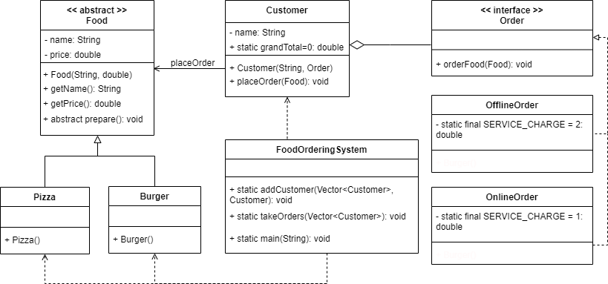
Figure 1: UML Class Diagram
Preparing Hawaiian Chicken... Hawaiian Chicken ordered online. Total: RM41.90
Preparing Double Cheeseburger... Double Cheeseburger ordered online. Total: RM19.35

Preparing Hawaiian Chicken... Hawaiian Chicken ordered offline. Total: RM42.90

Preparing Double Cheeseburger... Double Cheeseburger ordered offline. Total: RM20.35

Grand Total Sales = RM124.50
Figure 2: Expected output of the program

You are required to do the following tasks:
- Define a class named OnlineOrder: (5 marks)
  - This class should implement the Order interface.
  - Declare a constant (SERVICE_CHARGE) representing the service charge for online orders.
  - Define an orderFood() method that prepares the food, calculates the cost for online order food by adding the price of food with the service charge, which is RM1.00 for online orders and updates the grand total sales. Then, display the order and the cost of the order on the screen (refer to Figure 2).
- Define a class named OfflineOrder: (5 marks)
  - This class should implement the Order interface.
  - Declare a constant (SERVICE_CHARGE) representing the service charge for offline orders.
  - Define an orderFood() method that prepares the food, calculates the cost for offline order food by adding the price of food with the service charge, which is RM2.00 for offline orders and updates the grand total sales. Then, display the order and the cost of the order on the screen (refer to Figure 2).
- Define an abstract class named Food: (6 marks)
  - Define a constructor that takes arguments and initializes the member attributes with passed arguments.
  - Define getName() method that returns the food name.
  - Define getPrice() method that returns the food price.
  - Declare an abstract method named prepare(). Subclasses must define this method.

- Define a class named Pizza: (4 marks)
  - This class should inherit from the Food class.
  - Define a constructor and initializes the superclass’s attributes with “Hawaiian Chicken” as name and RM40.90 as price.
  - Define prepare() method that displays pizza preparing message.
- Define a class named Burger: (4 marks)
  - This class should inherit from the Food class.
  - Define a constructor and initializes the superclass’s attributes with “Double Cheeseburger” as name and RM18.35 as price.
  - Define prepare() method that displays burger preparing message.

- Define a class named Customer: (6 marks)
  - Define a constructor that takes arguments and initializes the member attributes with passed arguments.
  - Define placeOrder() method that places the food order made by the customer.

1 | // FoodOrderingSystem.java
2 | import java.util.*;
3
4 | interface Order {
5 | void orderFood(Food food);
6 | }
7
8 | class FoodOrderingSystem {
9 | //Method to add a customer to the system
10 | public static void addCustomer(Vector<Customer> cList, Customer c) {
11 | cList.add(c);
12 | }
13
14 | // Method to take orders from all customers in the system
15 | public static void takeOrders(Vector<Customer> cList) {
16 | for (Customer c: cList) {
17 | c.placeOrder(new Pizza());
18 | c.placeOrder(new Burger());
19 | }
20 | }
21
22 | public static void main(String[] args) {
23 | // Create a new customer list
24 | Vector<Customer> cList = new Vector<>();
25
26 | //Add customers to the system
27 | addCustomer(cList, new Customer("Haris", new OnlineOrder()));
28 | addCustomer(cList, new Customer("Aliya", new OfflineOrder()));
29
30 | //Take orders from all customers
31 | takeOrders(cList);
32 | System.out.printf("Grand Total Sales = RM%.2f\n",
33 | Customer.grandTotal);
34 | }
35 | }
Figure 3: Order and FoodOrderingSystem class definitions

